UNITED STATES HISTORY SECTION II
Part A
(Suggested writing time—45 minutes) Percent of Section II score—45
Directions: The following question requires you to construct a coherent essay that integrates your interpretation of Documents A-J and your knowledge of the period referred to in the question. High scores will be earned only by essays that both cite key pieces of evidence from the documents and draw on outside knowledge of the period.

- How successful were African Americans in achieving equality on the Home Front as well as the military? Explain your answer.

Document A
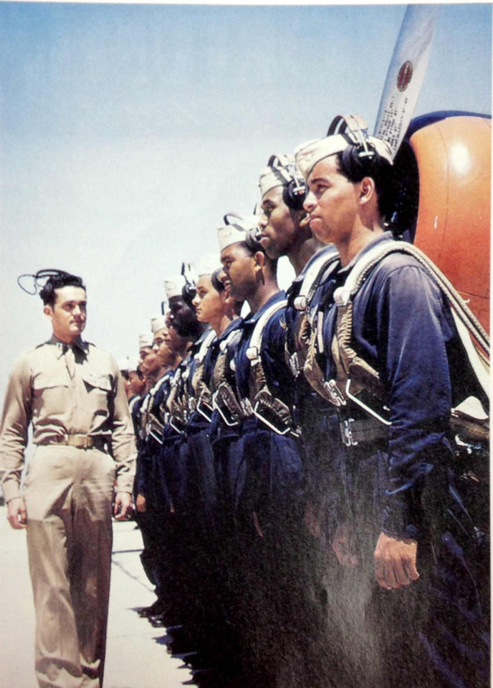

Document B
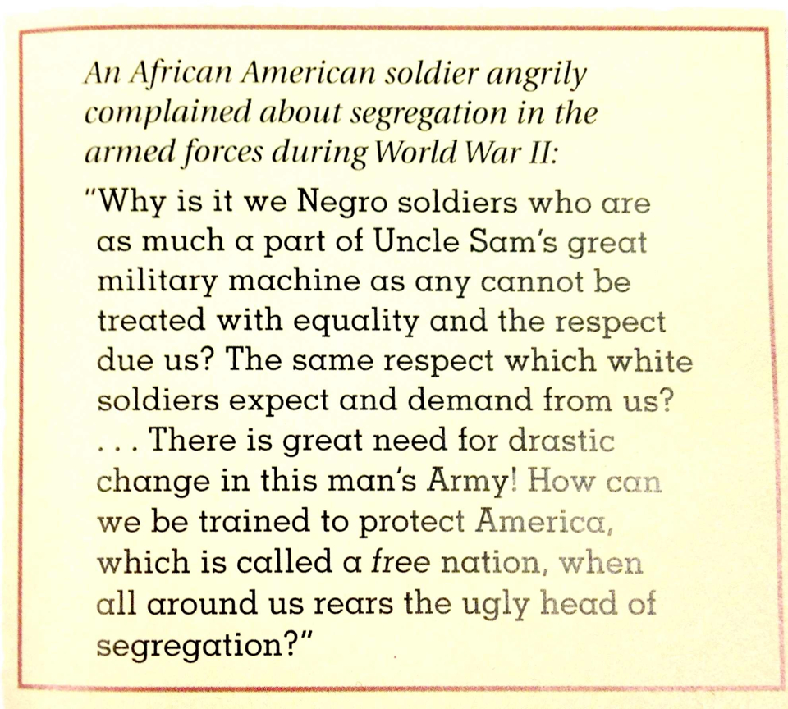

Document C
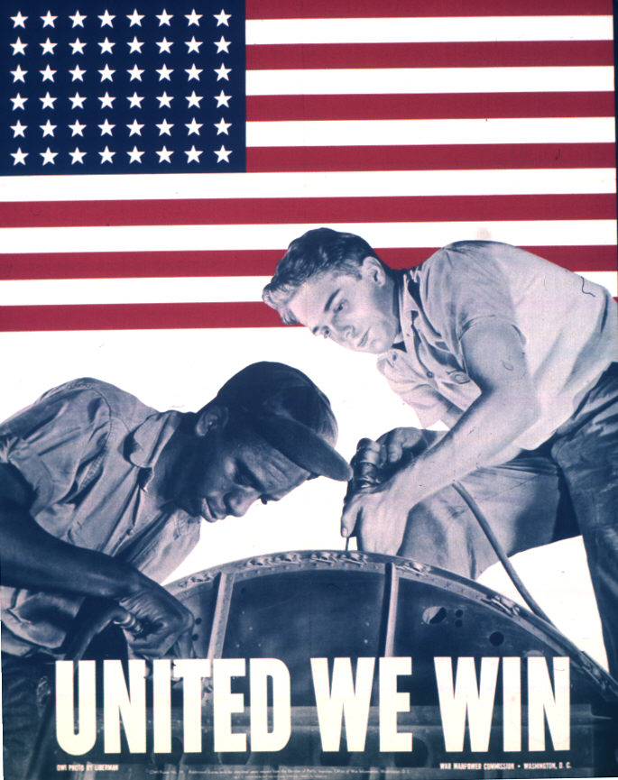

Document D
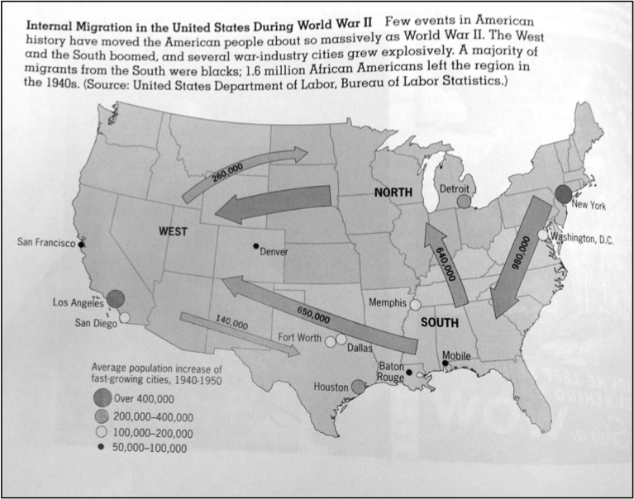

Document E
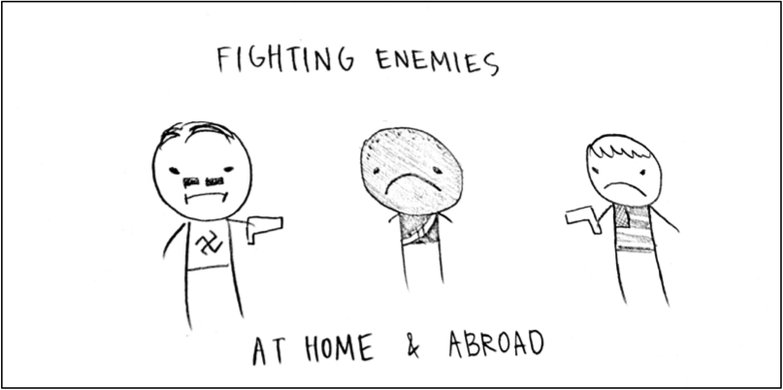

Document F
Source: Dempsey Travis, a writer and African-American war veteran, 1980
"The army was an experience unlike anything I've had in my life. I think of two armies, one black, one white. I saw German prisoners free to move around the camp, unlike black soldiers, who were restricted. The Germans walked right into the doggone places like any white American. We were wearin' the same uniform, but we were excluded."

