Question 1 — Document-Based Question (continued)

How successful were African Americans in achieving equality on the Home Front as well as the military? Explain your answer.

Document A

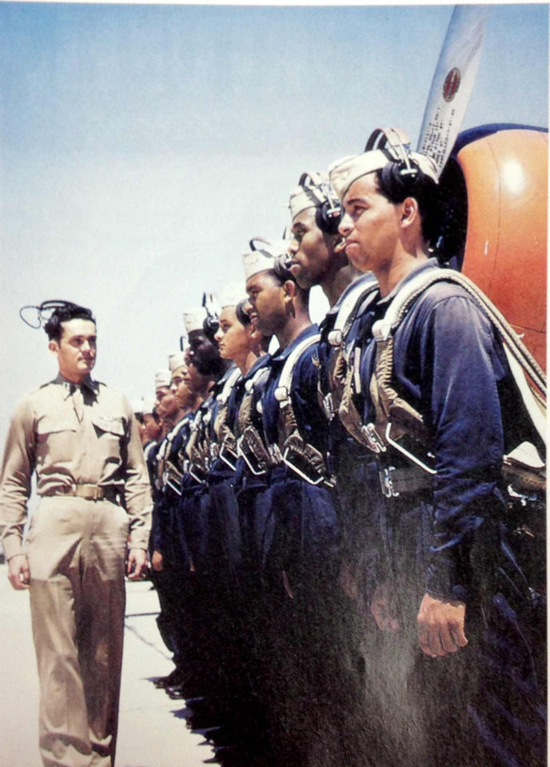
Document Information

- A white officer reviews the 99th Pursuit Squadron, also known as the ‘Tuskegee Airmen’.
- There was segregation in the military with the White Americans holding the more superior positions.
- The army assigned most African Americans to construction, long-shore and mess-hall service.

Document Inferences

- African Americans played important roles during World War 2.
- However, racism in America was not yet completely abolished even though the African Americans gained their rights after the Civil War.

