Question 1 — Document-Based Question (continued)

How successful were African Americans in achieving equality on the Home Front as well as the military? Explain your answer.

Document B

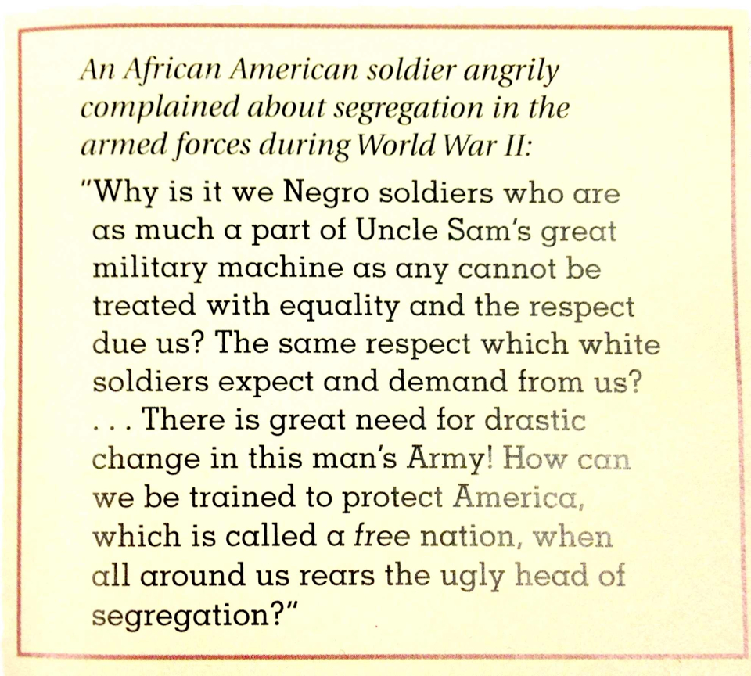
Document Information

- An African American soldier complained about segregation in the armed forces.
- The African American soldier wanted the rights that he and his fellow African Americans deserved, which was having the equal rights with White Americans.
- The African Americans were not treated with equality and respect even though America was a so-called ‘free nation’.

Document Inferences

- African Americans were angry about segregation in the military.
- African Americans were patriotic, but they were upset since they did not get respect from their hard work.

