Question 1 — Document-Based Question (continued)

How successful were African Americans in achieving equality on the Home Front as well as the military? Explain your answer.

Document C

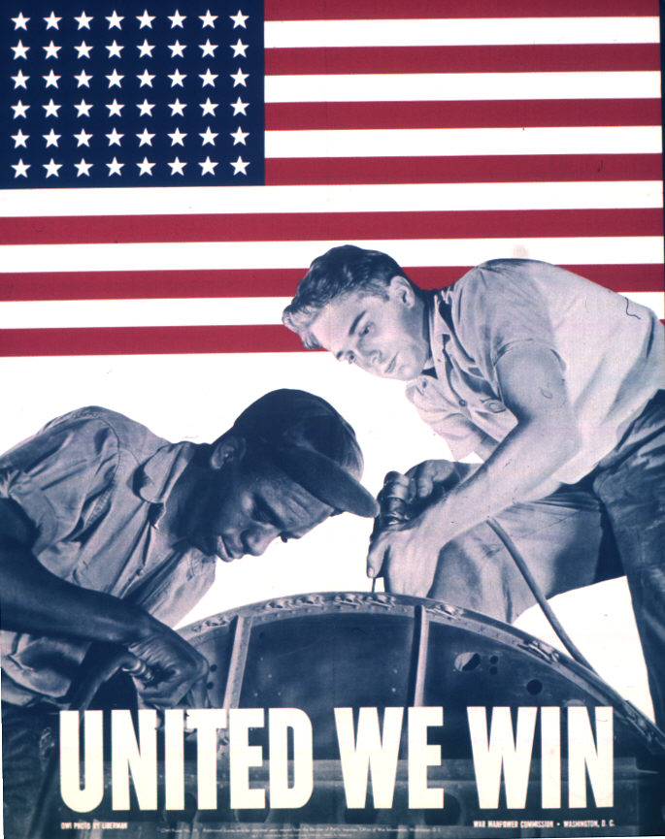
Document Information

- Although it seemed as though African American servicemen were respected as members of the armed services while in uniform during WWII, the Jim Crow Laws were still in effect; therefore, the African Americans were still discriminated against.
- More than two million African Americans went to work for defense plants, and another two million joined the federal civil service. These new opportunities drew more and more African Americans into cities and paved the way for economic mobility.
- On the Home Front, the U.S. government desperately needed workers to fill newly created defense jobs and factory positions left open by soldiers who had left to fight, so they used African Americans.

Document Inferences

- Some people believed that WWII would be won if White and African Americans worked together.
- African and White Americans worked together in factories or businesses pertaining to machinery.

