Question 1 — Document-Based Question (continued)

How successful were African Americans in achieving equality on the Home Front as well as the military? Explain your answer.

Document D
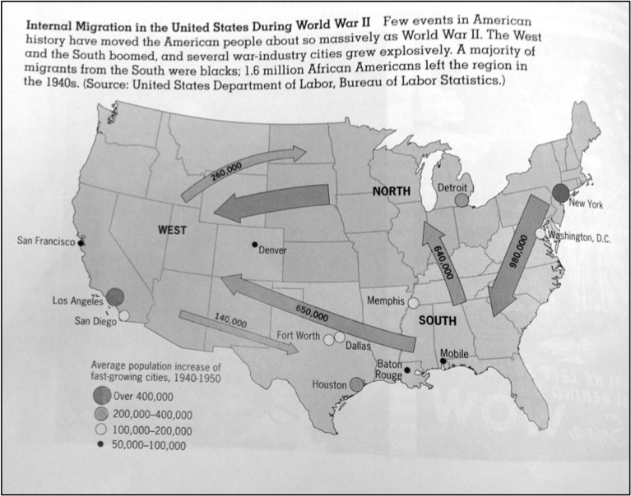
Document Information

- African Americans suffered "Jim Crow" laws in the South that segregated schools, restaurants, hotels, railroad cars, and even hospitals. Blacks were effectively kept from voting by laws requiring a literacy test (if you wanted to vote, you had to show you could read) and a poll tax (you had to pay to vote). Whites were exempted from either test by a "grandfather clause": if your grandfather voted, you could, too.
- Northern industries were going through an economic boom, especially as the war in Europe began creating a demand for war goods.
- There was a vast change throughout America as people moved and towards urban areas North and West. This relocation was called the Great Migration and it greatly affected the demographics of the United States of America.

Document Inferences

- California and New York had the greatest boom in population in the duration between 1940 and 1950 .
- Most of the people migrated from the South to the North or from the East to the West seeking jobs.

