Question 1 — Document-Based Question (continued)

Did African Americans have more impact on the Home Front or fighting abroad during WWII? Explain your answer.
Document E

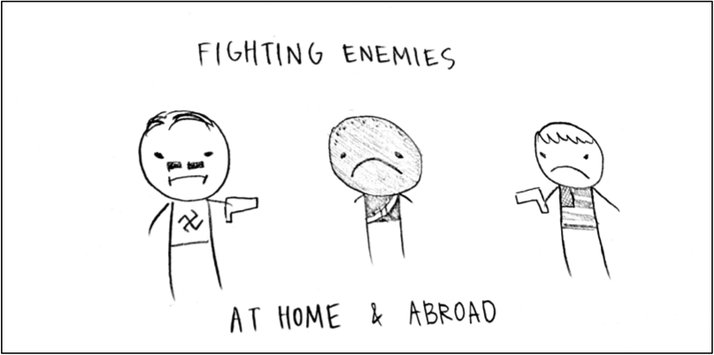
Document Information

- The African American is fighting against Germany for America, yet the White American opposes him.
- The African American finds this upsetting.
- Both Germany and the White Americans are opponents and hostile to the African American.

Document Inferences

- The African Americans were still looked down upon after the Civil War.
- African Americans tried to help their country but their own countrymen disliked them.

